LONG MELFORD

HOUSING & POPULATION DATA PROFILE
[Parish level]

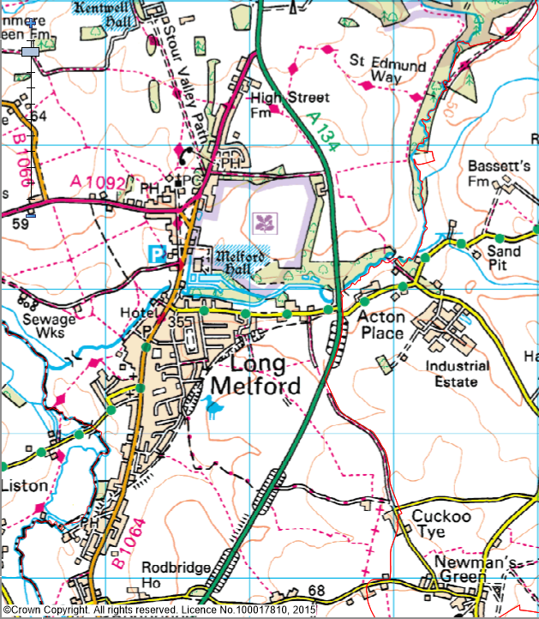
(Last Updated: October 2019)

This Parish Profile has been produced primarily to help inform local discussion on housing need.
Most of the data comes from the 2011 Census (accessible via the ONS website). Other data sources have also been used as appropriate, and will be updated periodically.

How many people live locally? | Children Under  16 | Working  Age Adults  (16 to 64) | People  Aged  65 + | Dependency Ratio
3,518 | 490 (13.9%) | 2,084 (59.3%) | 944 (26.8%) | 0.69
48.9% males  51.1% females | Babergh Avg = 18.1%  England Avg = 18.9% | Babergh Avg = 60.5%  England Avg = 64.7% | Babergh Avg = 21.4%  England Avg = 16.3% | Babergh Avg = 0.65  England Avg = 0.55

[Source: ONS 2011 Census: KS101EW & KS102EW] [Dependency Ratio = Ratio of Non-working Age to Working Age Population]

Single Pensioner Households | Single H/holds  < 65 years old | Lone Parent Families  with Dependent Children
324 | 272 | 60
19.5% of all Households  (Babergh Avg = 14.1%)  (England Avg = 12.4%) | 16.4% of all Households  (Babergh Avg = 14.0%)  (England Avg = 17.9%) | 19.6% of all families with dependent children  (Babergh Avg = 19.1%)  (England Avg = 24.5%)

[Source: ONS 2011 Census: KS105EW]

General Health (All Usual Residents)

Very Good  41.4% | Good  37.2% | Fair  15.7% | Bad  4.5% | Very Bad  1.2%
Babergh Avg = 46.6%  England Avg = 47.2% | Babergh Avg = 35.8%  England Avg = 35.2% | Babergh Avg = 13.2%  England Avg = 12.8% | Babergh Avg = 3.5%  England Avg = 3.6% | Babergh Avg = 0.9%  England Avg = 1.0%

[Source: ONS 2011 Census: QS302EW]

Total # Occupied  Households | Owned (Outright or with Mortgage) | Shared Ownership | Socially  Rented | Privately  Rented
1,661 | 1,090 (65.6%) | 8 (0.5%) | 261 (15.7%) | 267 (16.1%)
 | Babergh Avg = 71.9%  England Avg = 63.3% | Babergh Avg = 0.5%  England Avg = 0.8% | Babergh Avg = 13.1%  England Avg = 17.7% | Babergh Avg = 12.6%  England Avg = 16.8%

[Source: ONS 2011 Census: QS405EW]
- At the time of the 2011 Census some 89 dwellings (5.1% of all dwellings in Long Melford) appeared to be unoccupied. (Babergh Avg = 3.8%) [QS418EW]
Number of Bedrooms (Occupied Households)

None | 1 bed | 2 bed | 3 bed | 4 bed +
0 (0%) | 123 (7.4%) | 485 (29.2%) | 685 (41.2%) | 368 (22.2%)
Babergh Avg = 0.1%  England Avg = 0.2% | Babergh Avg = 6.3%  England Avg = 11.8% | Babergh Avg = 25.4%  England Avg = 27.9% | Babergh Avg = 42.0%  England Avg = 41.2% | Babergh Avg = 26.2%  England Avg = 18.9%

[Source: ONS 2011 Census: QS411EW]

Total # Occupied  Households | Total # with Under-Occupied bedrooms | Total # with Over-Occupied bedrooms
1,661 | 1,340 (80.7%) | 21 (1.3%)
 | Babergh Avg = 80.6% / England Avg = 68.7% | Babergh Avg = 1.5% / England Avg = 4.6%

[Source: ONS 2011 Census: QS412EW]

NET NEW RESIDENTIAL COMPLETIONS (Last 5 Years: April to March)
2013/14 | 2014/15 | 2015/16 | 2016/17 | 2017/18
6 | 3 | 4 | 2 | 1

[Source: Babergh & Mid Suffolk Joint Annual Monitoring Report]

Avg Price & No (in brackets) of Properties Sold in CO10 Postcode Area (Aug 2018)
Detached | Semi-det | Terraced | Flat | All
£414,610 (25) | £274,596 (26) | £227,560 (25) | £154,128 (7) | £292.441 (83)

[Source: Right Move website: Market Trends]

In Babergh, in 2017 …the average wage was £24,499. The average house price was £269,498. Therefore, the wage to house price ratio = x 11.00
[Source: ONS website: Median wages, median house prices and ratio calculation]

Other Information

  - County Councillor = Cllr Richard Kemp (Melford Division)

  - District Councillor = Cllr Elisabeth Malvisi & Cllr John Nunn (Long Melford Ward)

- Long Melford is identified as a Core Village in Policy CS2 of the Babergh Local Plan 2011-2013 (Core Strategy & Policies) DPD (Adopted Feb 2014)

  - Long Melford forms part of a wider ‘functional cluster’ that includes the following hinterland villages: Acton, Alpheton, Boxted, Cockfield, Great Waldingfield, Lawshall, Shimpling, Stanstead, Borley and Foxearth & Liston

  - Long Melford is well served is well served by a range of local shops and services

  - 82% of all households with at least one usual resident in Long Melford had use of gas central heating. Only 4.4% said that they were reliant on oil-fired heating [QS415EW]

  - The following Housing Association’s (Registered Providers) are known to be active in Long Melford: Flagship, Hastoe, Orbit, Sanctuary Hereward and Suffolk Housing Society

- The 2014 Suffolk Housing Survey shows that, across Babergh district:

  - 12% of all existing households contain someone looking for their own property over the next 3 years (mainly single adults without children). The types of properties they are interested in are flats / apartments, and smaller terraced or semi-detached houses. Although this is not their first preference, many accept that the private rented sector is their most realistic option.

  - 25% of households think their current property will not be suitable for their needs in 10 years’ time.

  - 2 & 3 bed properties are most sought after by existing households wishing to move.

  - Suitable housing options for more elderly people are less available within the current housing stock. 6% of all households have elderly relatives who may need to move to Suffolk within the next 3 years.

