NEWTON

HOUSING & POPULATION DATA PROFILE
[Parish level]

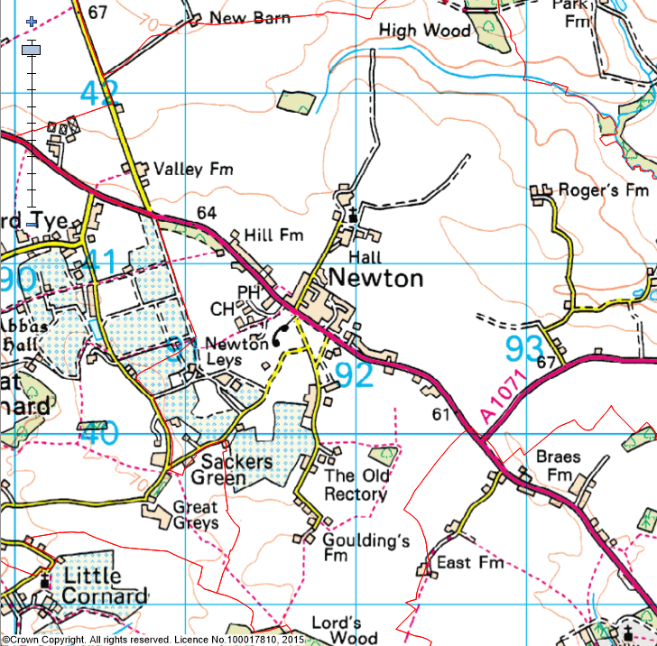

(Last Updated: October 2019)

This Parish Profile has been produced primarily to help inform local discussion on housing need.
Most of the data comes from the 2011 Census (accessible via the ONS website). Other data sources have also been used as appropriate, and will be updated periodically.

How many people live locally? | Children Under  16 | Working  Age Adults  (16 to 64) | People  Aged  65 + | Dependency Ratio
495 | 86 (17.4%) | 281 (56.7%) | 128 (25.9%) | 0.76
49.9% males  50.1% females | Babergh Avg = 18.1%  England Avg = 18.9% | Babergh Avg = 60.5%  England Avg = 64.7% | Babergh Avg = 21.4%  England Avg = 16.3% | Babergh Avg = 0.65  England Avg = 0.55

[Source: ONS 2011 Census: KS101EW & KS102EW] [Dependency Ratio = Ratio of Non-working Age to Working Age Population]

Single H/holds  < 65 years old | Single Pensioner Households | Lone Parent Families  with Dependent Children
25 | 21 | 12
12% of all Households  (Babergh Avg = 14.0%)  (England Avg = 17.9%) | 10% of all Households  (Babergh Avg = 14.1%)  (England Avg = 12.4%) | 23% of all families with dependent children  (Babergh Avg = 19.1%)  (England avg = 24.5%)

[Source: ONS 2011 Census: KS105EW]

General Health (All Usual Residents)

Very Good  47.3% | Good  33.5% | Fair  14.0% | Bad  4.2% | Very Bad  1.0%
Babergh Avg = 46.6%  England Avg = 47.2% | Babergh Avg = 35.8%  England Avg = 35.2% | Babergh Avg = 13.2%  England Avg = 12.8% | Babergh Avg = 3.5%  England Avg = 3.6% | Babergh Avg = 0.9%  England Avg = 1.0%

[Source: ONS 2011 Census: QS302EW]

Total # Occupied  Households | Owned (Outright or with Mortgage) | Shared Ownership | Socially  Rented | Privately  Rented
209 | 151 (72.2%) | 0 (0%) | 27 (12.9%) | 22 (10.5%)
 | Babergh Avg = 71.9%  England Avg = 63.3% | Babergh Avg = 0.5%  England Avg = 0.8% | Babergh Avg = 13.1%  England Avg = 17.7% | Babergh Avg = 12.6%  England Avg = 16.8%

[Source: ONS 2011 Census: QS405EW]
- At the time of the 2011 Census some 9 dwellings (4.1% of all dwellings in Newton) appeared to be unoccupied. (Babergh Avg = 3.8%) [QS418EW]
Number of Bedrooms (Occupied Households)

None | 1 bed | 2 bed | 3 bed | 4 bed +
1 (0.5%) | 8 (3.8%) | 49 (23.4%) | 76 (36.4%) | 75 (35.9%)
Babergh Avg = 0.1%  England Avg = 0.2% | Babergh Avg = 6.3%  England Avg = 11.8% | Babergh Avg = 25.4%  England Avg = 27.9% | Babergh Avg = 42.0%  England Avg = 41.2% | Babergh Avg = 26.2%  England Avg = 18.9%

[Source: ONS 2011 Census: QS411EW]

Total # Occupied  Households | Total # with Under-Occupied bedrooms | Total # with Over-Occupied bedrooms
209 | 174 (83.3%) | 6 (2.9%)
 | Babergh Avg = 80.6% / England Avg = 68.7% | Babergh Avg = 1.5% / England Avg = 4.6%

[Source: ONS 2011 Census: QS412EW]

NET NEW RESIDENTIAL COMPLETIONS (Last 5 Years: April to March)
2013/14 | 2014/15 | 2015/16 | 2016/17 | 217/18
0 | 1 | 1 | 1 | 0

[Source: Babergh & Mid Suffolk Joint Annual Monitoring Report]

Avg Price & No (in brackets) of Properties Sold in CO10 Postcode Area (Aug 2018)
Detached | Semi-detached | Terraced | Flat | All
£434,836 (29) | £274,596 (26) | £227,560 (25) | £154,128 (7) | £292.441 (83)

[Source: Right Move website: Market Trends]

BABERGH
In Babergh, in 2017 …the average wage was £24,499. The average house price was £269,498. Therefore, the wage to house price ratio = x 11.00
[Source: ONS website: Median wages, median house prices and ratio calculation]

Other Information

- County Councillor = Cllr James Finch (Stour Valley Division)

- District Councillor = Cllr Lee Parker (Bures St Mary Ward)

- Newton is identified as a Hinterland Village in Policy CS2 of the Babergh Local Plan 2011-2013 (Core Strategy & Policies) DPD (Adopted Feb 2014)

- Newton is part of two wider ‘functional clusters’, one centred on Sudbury & Great Cornard and the other centred on the Core Village of Boxford
- Newton Parish Council published the results of their Parish Survey in 2011

- There are a limited range of services available in Newton, with the nearest shops / post office being located in nearby Great Waldingfield. Newton does have a Parish Church and a Village Hall and a Pub / Restaurant. It also plays host to Newton Green Golf Club

- 63% of all households with at least one usual resident in Newton are reliant on oil-fired heating [QS415EW]

- The following Housing Association’s (Registered Providers) are currently known to be active in Newton: Flagship and Orwell

- The 2014 Suffolk Housing Survey shows that, across Babergh district:

  - 12% of all existing households contain someone looking for their own property over the next 3 years (mainly single adults without children). The types of properties they are interested in are flats / apartments, and smaller terraced or semi-detached houses. Although this is not their first preference, many accept that the private rented sector is their most realistic option.

  - 25% of households think their current property will not be suitable for their needs in 10 years’ time.

  - 2 & 3 bed properties are most sought after by existing households wishing to move.

  - Suitable housing options for more elderly people are less available within the current housing stock. 6% of all households have elderly relatives who may need to move to Suffolk within the next 3 years.

