SYLEHAM

HOUSING & POPULATION DATA PROFILE
[Parish level]

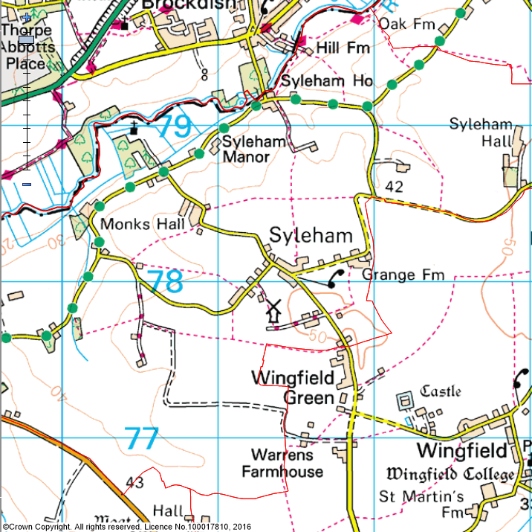

(Last Updated: October 2019)

This Parish Profile has been produced primarily to help inform local discussion on housing need
Most of the data comes from the 2011 Census (accessible via the ONS website)
Other data sources have also been used as appropriate, and will be updated periodically

How many people live locally? | Children Under  16 | Working  Age Adults  (16 to 64) | People  Aged  65 + | Dependency Ratio
180 | 12 (6.7%) | 118 (65.5%) | 50 (27.8%) | 0.53
51.7% Males  48.3% Females | Mid Sflk Avg = 18.4%  England Avg = 18.9% | Mid Sflk Avg = 61.5%  England Avg = 64.7% | Mid Sflk Avg = 20.1%  England Avg = 16.3% | Mid Sflk Avg = 0.63  England Avg = 0.55

[Source: ONS 2011 Census: KS101EW & KS102EW] [Dependency Ratio = Ratio of Non-working Age to Working Age Population]

Single Pensioner Households | Single H/holds  < 65 years old | Lone Parent Families  with Dependent Children
10 | 9 | 1
11.8% of all Households  Mid Suffolk Avg = 12.9%  England Avg = 12.4% | 10.6% of all Households  Mid Suffolk Avg = 12.4%  England Avg = 17.9% | 7.7% of all families with dependent children  Mid Suffolk Avg = 17.7%  England avg = 24.5%

[Source: ONS 2011 Census: KS105EW]

General Health (All Usual Residents)

Very Good  41.1% | Good  45.0% | Fair  10.0% | Bad  3.3% | Very Bad  0.6%
Mid Sflk Avg = 47.9%  England Avg = 47.2% | Mid Sflk Avg = 35.3%  England Avg = 35.2% | Mid Sflk Avg = 12.8%  England Avg = 12.8% | Mid Sflk Avg = 3.1%  England Avg = 3.6% | Mid Sflk Avg = 0.8%  England Avg = 1.0%

[Source: ONS 2011 Census: QS302EW]

Total # Occupied  Households | Owned (Outright or with Mortgage) | Shared Ownership | Socially  Rented | Privately  Rented
85 | 74 (87.1%) | 0 (0%) | 0 (0%) | 9 (10.6%)
 | Mid Sflk Avg = 75.1%  England Avg = 63.3% | Mid Sflk Avg = 0.8%  England Avg = 0.8% | Mid Sflk Avg = 11.3%  England Avg = 17.7% | Mid Sflk Avg = 11.2%  England Avg = 16.8%

[Source: ONS 2011 Census: QS405EW]
- At the time of the 2011 Census some 10 dwellings (10.5% of all dwellings in Syleham) appeared to be unoccupied. (Mid Suffolk Avg = 3.8%) [QS418EW]
Number of Bedrooms (Occupied Households)

None | 1 bed | 2 bed | 3 bed | 4 bed +
0 (0%) | 0 (0%) | 12 (14.1%) | 43 (50.6%) | 30 (35.3%)
Mid Sflk Avg = 0.1%  England Avg = 0.2% | Mid Sflk Avg = 6.0%  England Avg = 11.8% | Mid Sflk Avg = 25.0%  England Avg = 27.9% | Mid Sflk Avg = 40.4%  England Avg = 41.2% | Mid Sflk Avg = 28.5%  England Avg = 18.9%

[Source: ONS 2011 Census: QS411EW]

Total # Occupied  Households | Total # with Under-Occupied bedrooms | Total # with Over-Occupied bedrooms
85 | 79 (92.9%) | 0 (0%)
 | Mid Sflk Avg = 80.8% / England Avg = 68.7% | Mid Sflk Avg = 1.6% / England Avg = 4.6%

[Source: ONS 2011 Census: QS412EW]

NET NEW RESIDENTIAL COMPLETIONS (Last 5 Years: April to March)
2013/14 | 2014/15 | 2015/16 | 2016/17 | 2017/2018
0 | 0 | 0 | 0 | 0

[Source: Babergh & Mid Suffolk DC - Annual Monitoring Data]

Avg Price & No (in brackets) of Properties Sold in IP21 Postcode (Sept 2015)
Detached | Semi-Det’ | Terraced | Flat | All
£342,500 (6) | £169,833 (3) | £146,250 (2) | £0 (0) | £259,727 (11)

[Source: Right Move website: Market Trends]

MID SUFFOLK
In Mid Suffolk, in 2017 …the average wage was £25,070. The average house price was £255,000. Therefore, the wage to house price ratio = x 10.17
[Source: ONS website: Median wages, median house prices and ratio calculation]

Other Information

- County Councillor = Cllr Guy McGregor (Hoxne & Eye Division)

- District Councillor = Cllr Lavinia Hadingham (Fressingfield Ward)

- Syleham is identified as a Countryside Village in Policy CS1 of the Mid Suffolk Core Strategy DPD (Adopted Sept 2008)

- The Syleham Parish Plan was published in 2009. The Action Plan was updated in 2011

- There are a limited range of services available in Syleham but these do include a Parish Church and Village Hall

- 69% of all households in Syleham with at least one usual resident are reliant on oil-fired heating [QS415EW]

- There are no Housing Association’s (Registered Providers) currently known to be active in Wingfield

- The 2014 Suffolk Housing Survey shows that, across Mid Suffolk district:

  - 12% of all existing households contain someone looking for their own property over the next 3 years (mainly single adults without children). The types of properties they are interested in are flats / apartments, and smaller terraced or semi-detached houses. Although this is not their first preference, many accept that the private rented sector is their most realistic option.

  - 25% of households think their current property will not be suitable for their needs in 10 years’ time.

  - 2 & 3 bed properties are most sought after by existing households wishing to move.

  - Suitable housing options for more elderly people are less available within the current housing stock. 6% of all households have elderly relatives who may need to move to Suffolk within the next 3 years.

