Introduction

Babergh and Mid Suffolk District Councils (‘the Councils’) offer Community Grants to organisations that deliver community projects, activities or support within Babergh and Mid Suffolk. The Gateway 14 Community Benefit Fund is administered by the Councils on behalf of Gateway 14.

These notes are designed to help you complete our Gateway 14 Community Benefit Fund application form and we suggest that you read them through fully before you complete the forms.

Details on our available Grants can be found on our website. View information on Community Grants in Babergh or Mid Suffolk.

The Gateway 14 Community Benefit Fund

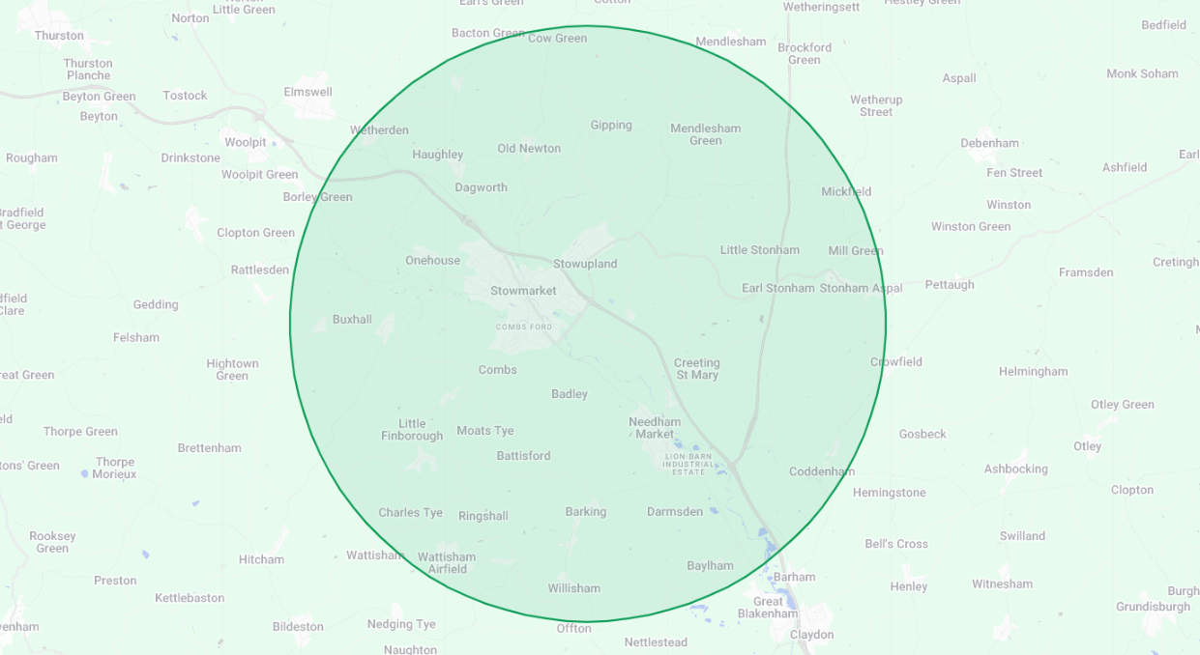
Gateway 14 is the largest business, innovation and logistics park in East Anglia. The site has the potential to deliver thousands of jobs in the region, while also delivering enhanced biodiversity through 25.3 acres of landscapying and amenity use. The Gateway 14 Community Benefit Fund has been established to support community groups and provide valuable investment into community initiatives within a 5 mile radius of Gateway 14. View a map of the Fund’s eligible area.
The Fund is eligible towards revenue or capital costs or activities, up to 100% of total project costs (to a maximum grant of £5,000). Applicants can make one application per financial year to the Fund.

Applications must demonstrate a clear community need for their project/organisation and wider community benefit. Applications which are not fully filled or lack required supporting documentation will not be considered eligible.

Match funding is not required, though may be encouraged for some applications.

Fund Priorities

All applications to the Gateway 14 Community Benefit Fund must align to one or more of the priorities of the Fund.

Skills and Education
Projects or organisations which provide educational opportunities or skills development to residents, communities or organisations.

Sustainability
Projects which improve the financial sustainability or resilience of community groups or social enterprises, such as community pubs and shops or CICs. This could include training or organisational development.

Environment
Projects or organisations seeking to deliver environmental projects such as improving biodiversity, improving the energy efficiency of community buildings or the creation of new wildlife areas and habitats.

Innovation
Projects or organisations seeking to provide or trial a new or improved service or activity within the eligible area.

Sport
Projects or organisations providing physical activity opportunities for residents and communities, such as improved sporting facilities or sporting projects improving people’s health and wellbeing.

Terms and Conditions

Organisations
Applications for grants will only be considered from constituted Voluntary, Community, Faith and Social Enterprise (VCFSE) organisations which:

- Are based within, or provide a service for the benefit residents and communities within the eligible funding area
- Are capable of obtaining from their own funds, or other sources, sufficient funding to cover the total project costs
- Are financially viable, as evidenced by audited or independently examined accounts
- Have Safeguarding, Health and Safety and Equal Opportunities policies in place for employees, volunteers and service users
- Provide services which align with the Fund’s priorities, do not duplicate services already being provided/grant aided, and will meet proven identified needs. In the case of 'start-up' initiatives, evidence of the need for the new service needs to be supported and reflect community demand

Ineligible Organisations
The Gateway 14 Community Benefit Fund is not available for:

- Private individuals
- For-profit businesses
- Statutory authorities
- Schools where there is no wider community benefit (defined as different sections of the community, and in addition to current parents of school children), and not to support normal school or business activity
- Churches where there is no wider community benefit
- Community groups without an independent bank account or constitution
- Activities promoting religious or political beliefs
- Services commenced or goods ordered prior to Grants being awarded

Community Interest Companies
A Community Interest Company (CIC) is a form of limited company that may be limited by shares or guarantee. The Council only accepts applications for Community Grants from CICs that are limited by guarantee.

A CIC operates like a standard limited company, with directors overseeing its activities, but its purpose must benefit the community, not generate profit for members. The concept of community can have a wide range of meanings, from the population to a section of the community, such as the residents of a particular area or a group of people suffering from a particular disadvantage.

If directors are also the only members, they must act collectively, share responsibility, and comply with collective decisions—even if they personally disagree. CIC directors can be paid a salary which is treated as an employee’s wage for tax purposes. Therefore, to be eligible for Council funding, a CIC must:

- Be limited by guarantee
- Have at least two unrelated directors
- Evidence that no single director has excessive control (i.e., no individual holds 50% or more of voting rights; has the power to appoint/remove directors; or is listed as a Person with Significant Control (PSC) with Companies House)

Your governing documents must demonstrate:

- A clear social purpose
- That profits are not distributed
- A minimum of two directors, with no Person with significant Control (PSC) registered with Companies House
- A quorum of at least two directors for meetings
- An asset lock to ensure remaining assets go to a similar organisation upon closure (if you have not nominated an asset lock body within your articles of association, you will need the regulators consent to transfer any residual assets)

Trading: Your enterprise should be generating income through trading or contracts (or planning to). Grants are generally not awarded for core running costs unless an income stream is already established.

Accounts: You must provide annual accounts showing:

- All income sources, including traded income, grants, and donations. If this is not clearly shown, extra information will be required.
- Show defined expenditure for the past 12 months.
- Note any SCF funding as a restricted grant.

You may also need to disclose:

- The number of directors who are paid employees
- The salary levels of paid directors
- Your last CIC34 Annual CIC Report

VAT
If your organisation is registered for and can reclaim VAT, any Grant awarded will be exclusive of VAT. If your organisation is unable to reclaim VAT, Grants awarded will be inclusive of VAT.

Conditions
- Projects should deliver community benefits, and these benefits as well as project outcomes should be identified as part of the application process.
- All services/projects need to be delivered within a specified time period. By the end of the period the services/project should be sustainable, or have a plan in place for future funding.
- To ensure best value for money, a minimum of two quotes are required for capital purchases and expenditure.
- Projects cannot be retrospectively funded, i.e. applications cannot be submitted for projects or purchases already completed/commenced.
- Where appropriate, applicants will need to provide evidence of their land tenure, usually ownership (freehold) or a lease with at least 10 years un-expired at the time of application.
- A grant approval given in advance of other decisions required from the Council does not imply that any other form of consent by the Council will be forthcoming, such as Planning Permission, Building Regulations approval or Community Infrastructure Levy bids.
- Some applications will need to be supported with additional documentation so that an accurate and complete understanding of the proposal is provided. The amount of information and supporting documentation to be provided should be proportionate to the project, namely its size, complexity, and cost, and this can be discussed with the Grants Team prior to application submission.
- The Council reserves the right to request a copy of any applying organisation’s policies or constitution prior to an application being assessed or funding being released to a successful applicant.
- If any conditions are breached, the Council reserves the right to seek recovery of all or part of the grant. If you do not immediately repay these monies, when requested to do so by the Council, the Council reserves the right to commence County Court proceedings for recovery of the outstanding monies, together with interest and Legal costs.
- Funding will not be released until the full funding package for the project has been evidenced.

Eligible Projects and Costs

A range of projects and costs can be applied for through the Gateway 14 Community Benefit Fund. Applications can include more than one element, i.e., an application can encompass capital and revenue costs.

Capital Projects
Funding is available towards repairs or improvements to social infrastructure, such as village halls, play areas and playing fields, sports clubs and facilities, and youth groups. Funding is also available to Charities seeking to make capital purchases or improvements to their facilities.

Funding is not available towards the purchase of land, or projects where there is not wider community access.

Revenue Costs
Grants can be awarded towards an organisation’s core running costs, such as salaries or administrative costs. Costs which can be applied for can include the following:

- Management and administration
- HR and payroll
- General office expenses
- Accountancy and audit
- Communications and outreach
- Monitoring, evaluation, and learning
- Governance, regulatory, and compliance costs
- Facility and energy costs

Parish and Town Councils are ineligible to apply towards revenue costs. Funding is limited to one financial year’s running costs.

Revenue Projects
Funding is available towards the delivery and running costs of new and existing community groups and services. This may include wellbeing groups, projects that support communities to reduce isolation, improve social contact and improve wellbeing.

Ineligible projects and costs include the following:
- Purchase of equipment where there is no clear evidence of need
- Fundraising events
- One-off revenue costs such as trips and outings, without a long-term benefit to the community
- Grants, bursaries and vouchers to individuals

Process

£30,000 per annum is available to apply for. There will be one application window per financial year. The application window for 2025/26 will open 28th November 2025 and close 1st March 2026. Applicants will receive a notification of the outcome of their application within 4 weeks of the application window closing. If funding is not fully allocated, then a second application window will be opened. Any funding not allocated in 2025/26 will be carried forward into 2026/27.

Pre-Application
Applicants may wish to have pre-application discussions with the Grants Team. This can be started with a Grant Enquiry Form or an email enquiry to the Grants Inbox. Site visits to prospective projects, or online meetings to discuss projects, are also available.
  - Application Process
Completed grant applications to be emailed to: BMSDCGrants@baberghmidsuffolk.gov.uk by no later than the stipulated deadline.

Each completed application form to be accompanied by a copy of latest accounts and (if a capital project) a minimum of 2 quotes for any proposed works, or a valid reason if a single quote is provided. The Councils reserve the right to request copies of Policies (Equal Opportunities, Health & Safety, Child and Adult Safeguarding) or other supporting documentation where applicable.
  - Assessment
All applications will be scored by a publicly available scoring matrix. Applications which score under 50% on the Gateway 14 Community Benefit Fund Scoring Matrix will not be considered eligible for funding.
In assessing your application priority will be given to applications that demonstrate wide community engagement, community involvement and evidenced benefit. Any application for funding to support or extend existing community assets and services must also demonstrate and evidence clear community need and evidence this.
Priority will be given to applications with the widest community benefit. Priority will also be given to ensure funding is equitable across the Fund’s priorities.

Offer Letters
Successful applicants will receive an offer letter setting out conditions, outcomes and the period during which the service/project needs to be completed and the grant offer claimed. Offers are valid for 4 weeks, and after this period the offer will expire.

If any service/project fails to meet any of the conditions contained in the grant offer letter or the agreed targets/outputs, then consideration will be given to the grant offer being withdrawn and any grant monies already paid being recovered together with any interest applicable.

Payment
For revenue cost applications, funding will be released on receipt of a signed offer letter. For Capital or pre-project cost applications, funding will be released on receipt of invoices/receipts showing that expenditure has taken place.

If any service/project fails to meet any of the conditions contained in the grant offer letter or the agreed targets/outputs, then consideration will be given to the grant offer being withdrawn and any grant monies already paid being recovered together with any interest applicable.

Contact

If you have any queries, would like more information or would like to discuss a potential project and funding application, please email the Grants Team at BMSDCGrants@baberghmidsuffolk.gov.uk.

