Contents
1. Introduction 1
2. Catchment and Landscape Nature Recovery Grant 2
3. Terms and Conditions 2
3.1. Organisations 2
3.2. Community Interest Companies 3
3.3. Ineligible Organisations, Activities and Costs 3
3.4. VAT 4
3.5. Conditions 4
3.6. Outcomes and Indicators 5
3.7. Collaboration and Scale 6
3.8. Timelines 6
3.9. Security of Tenure 6
3.10. Offer Letters 6
4. Eligible Costs 6
4.1. Pre-Project Costs 7
4.2. Capital Projects 7
4.3. Revenue Costs 7
4.4. Match Funding 7
4.5. Application Process 7
4.6. Expression of Interest 8
4.7. Full Application 8
4.8. Assessment 8
4.9. Payment 11
5. Contact 11

Introduction

Mid Suffolk District Council offers Community Grants to organisations that deliver community support, projects or activities within Mid Suffolk. These notes are designed to help you complete our Community Nature Recovery Grant application forms and we suggest that you read them through fully before you complete the forms.

Details on our available Grants can be found on our website. View information on Community Grants in Mid Suffolk.

Catchment and Landscape Nature Recovery Grant

The Catchment and Landscape Nature Recovery Grant is aimed at supporting projects operating within river catchments involving multiple sites, stakeholders and landowners, delivering nature recovery, water management and community benefits at landscape-scale. The grant encourages projects that look beyond individual sites, focussing on measures that require a holistic and collaborative approach to issues that affect large areas and many communities.

Through this funding, we want to:
- Support delivery of the Mid Suffolk District Council Biodiversity Action Plan, through projects that contribute towards the retention, enhancement and creation of the priority habitats, or support the priority species.
- Support delivery of the Suffolk Local Nature Recovery Strategy, through projects that support the priority habitats, assemblages and species, or that take place in locations identified within the mapping as important for nature recovery.
- Support natural flood management measures, to address the causes of flooding, seeking interventions that are both sustainable for landowners and beneficial to biodiversity
- Support improvements in water quality, including identifying the sources of pollution and poor water quality, implementing changes in land and utilities management to address these.
- Support measures to improve water security, recognising the value of this scarce resource in a landscape with increasing water demands, in particular schemes that increase water storage.
- Support our communities, through co-benefits, such as natural flood management, improving air and water quality, community food production and improving health and wellbeing.
Applicants can only make one application per project per financial year to the Catchment and Landscape Nature Recovery Grant. Priority will be given to new applicants. Match funding is not essential, though is encouraged as it is likely to form part of the project.

Applications must demonstrate a clear need for their project/organisation within Mid Suffolk and wider community benefit. Applications which are not fully complete, or lack required supporting documentation, will not be considered eligible.

The Grant is available to support revenue, capital or pre-project costs or activities, up to 100% of total project costs (from £50,000 to a maximum grant of £200,000). However, it does not cover costs of activities prior to application.

Terms and Conditions

Organisations
Applications for grants will only be considered from constituted Voluntary, Community, Faith and Social Enterprise (VCFSE) organisations which:

- Are capable of obtaining from its own funds or other sources sufficient funding to cover the total project costs
- Are financially viable, as evidenced by audited, independently examined accounts or financial business strategy.
- Have Child and Adult Safeguarding, Health and Safety and Equal Opportunities policies for employees, volunteers and attendees
- Provide services which align with the Council’s priorities, do not duplicate services already being provided/grant aided, and will meet proven identified needs.

Community Interest Companies
A Community Interest Company (CIC) is a form of limited company that may be limited by shares or guarantee. The Council only accepts applications for Community Grants from CICs that are limited by guarantee.

A CIC operates like a standard limited company, with directors overseeing its activities, but its purpose must benefit the community, not generate profit for members. The concept of community can have a wide range of meanings, from the population to a section of the community, such as the residents of a particular area or a group of people suffering from a particular disadvantage.

If directors are also the only members, they must act collectively, share responsibility, and comply with collective decisions—even if they personally disagree. CIC directors can be paid a salary which is treated as an employee’s wage for tax purposes. Therefore, to be eligible for Council funding, a CIC must:

- Be limited by guarantee
- Have at least two unrelated directors
- Evidence that no single director has excessive control (i.e., no individual holds 50% or more of voting rights; has the power to appoint/remove directors; or is listed as a Person with Significant Control (PSC) with Companies House)

Your governing documents must demonstrate:

- A clear social purpose
- That profits are not distributed
- A minimum of two directors, with no Person with significant Control (PSC) registered with Companies House
- A quorum of at least two directors for meetings
- An asset lock to ensure remaining assets go to a similar organisation upon closure (if you have not nominated an asset lock body within your articles of association, you will need the regulators consent to transfer any residual assets)

Trading: Your enterprise should be generating income through trading or contracts (or planning to). Grants are generally not awarded for core running costs unless an income stream is already established.

Accounts: You must provide annual accounts showing:

- All income sources, including traded income, grants, and donations. If this is not clearly shown, extra information will be required.
- Show defined expenditure for the past 12 months.

You may also need to disclose:

- The number of directors who are paid employees
- The salary levels of paid directors
- Your last CIC34 Annual CIC Report

Ineligible Organisations, Activities and Costs
Community Nature Recovery Grants are not available for:

- Private individuals*
- For-profit businesses*
- Individual town and parish councils*
- Revenue funding for statutory duties
- Schools where there is no wider community benefit
- Churches where there is no wider community benefit
- Community groups without an independent bank account
- Activities promoting religious or political beliefs
- Services commenced or goods ordered prior to Grants being awarded

* Except where these are part of a consortium

VAT
If your organisation is registered for and can reclaim VAT, any Grant awarded will be exclusive of VAT. If your organisation is unable to reclaim VAT, Grants awarded will be inclusive of VAT.

Conditions
- Projects should deliver biodiversity, water management and community benefits, and these benefits as well as project outcomes should be identified as part of the application process.
- All services/projects need to be delivered within a period of 12 months, unless justification is provided for a different timescale. By the end of the period the services/project should be sustainable or have a plan in place for future funding.
- To ensure best value for money, a minimum of two quotes are required for capital purchases and expenditure.
- Projects cannot be retrospectively funded, i.e. applications cannot be submitted for projects or purchases already completed/commenced.
- Applicants will need to provide evidence of land tenure, usually ownership (freehold) or a lease with at least 10 years un-expired at the time of application and evidence of permission for the proposed project from a landlord. Where the applicant is acting on behalf of other landowners or tenants, evidence of tenure and the landowner’s or tenant’s agreement to the proposal is required.
- A grant approval given in advance of other decisions required from the Council or other relevant regulatory body does not imply that any other form of consent by the Council or other body will be forthcoming, such as Planning Permission, Building Regulations approval, licences, permits or Community Infrastructure Levy bids.
- Some applications will need to be supported with additional documentation so that an accurate and complete understanding of the proposal is provided. The amount of information and supporting documentation to be provided should be proportionate to the project, namely its size, complexity, and cost, and this can be discussed with the Grants Team prior to application submission.
- Where the application is for a project or service that extends beyond the boundaries of the Mid Suffolk area, consideration will be given to the funding secured from neighbouring local authorities or alternative funding sources supporting that proportion of the project outside of Mid Suffolk, when assessing the level of Mid Suffolk support applicable.
- The Council reserves the right to request a copy of any applying organisation’s policies or constitution prior to an application being assessed or funding being released to a successful applicant.
- If any conditions are breached, the Council reserves the right to seek recovery of all or part of the grant. If you do not immediately repay these monies, when requested to do so by the Council, the Council reserves the right to commence County Court proceedings for recovery of the outstanding monies, together with interest and Legal costs.
- Our decisions are final and there is no appeal process.
- Funding will not be released until the full funding package for the project has been evidenced.

Outcomes and Indicators
The Application Form requires outcomes and indicators to be provided. If your application for funding is successful, it gives us an agreed framework within which we can monitor progress.

Outcomes are the intended results a project or organisation aims to achieve. These will relate to the difference a project or grant has made.

Indicators are the means by which outcomes will be measured and can be quantitative (such as number of people using a facility within a specified timeframe) or qualitative (such as user feedback).

Examples of potential outcomes and indicators can be seen below. Please note that applications will need to provide a suite of outcomes and indicators for nature recovery, water management and community benefit:
Outcome | Habitat connectivity is increased across the project area
Indicator 1 | Increase of X in the number / length of hedgerows planted / widened headlands / green corridors, as compared with Y number currently recorded
Indicator 2 | Woodland X and Woodland Y are connected by new planting

Outcome | Himalayan balsam decreases across the project area
Indicator 1 | Decrease of X in the number of recordings of Himalayan balsam, as compared with Y number currently recorded
Indicator 2 | Increase in the area / number of locations in which species control is carried out, compared to current area

Outcome | Water quality improves
Indicator 1 | Levels of E. coli recorded decrease following the implementation of interventions, compared to baseline values
Indicator 2 | Measured oxygen content in the water at specific points increases compared to baseline values

Outcome | The river has increased resilience to low and high flows
Indicator 1 | The landscape has increased ability to hold more water and release it more slowly, compared to the baseline
Indicator 2 | Reduction in fluctuation of flow rate compared to current records

Outcome | [Road name] is no longer blocked by flooding after periods of heavy rain
Indicator 1 | Decrease in the number / cessation of flooding incidents leading to road closure or obstruction post-intervention compared to current data
Indicator 2 | Increased area of flood plain upstream of [road name] compared to current data

Outcome | Increased community engagement with the river
Indicator 1 | Increased number of volunteer hours on citizen science projects compared to current data
Indicator 2 | Increased number of volunteers participating in organised events / community group compared to current data

Collaboration and Scale
In assessing your application priority will be given to applications that look beyond individual sites, focussing on measures that require a holistic and collaborative approach to issues that affect large areas and many communities.

Timelines
Applications must provide a timeline for delivery. This will need to cover:
- Project start date
- Key milestones during the project
- Project end date
The timeline needs to be realistic and achievable. This includes consideration given to:
- Relevant environmental legislation, such as avoiding work during periods that may impact on protected species
- Carrying out planting during the appropriate season
- Expected lead-in time for contractors
- Time required for legal agreements and permissions

Security of Tenure
Applicants must either:
- Own the land to which the application relates (freehold)
- Have a lease agreement with at least 10 years remaining (leasehold)
- Have written confirmation that all participating landowners agree to the proposed project

Offer Letters
Successful applicants will receive an offer letter setting out conditions, outcomes and the period during which the service/project needs to be completed. Offers are valid for 28 days from the date of the offer, and after this period the offer will expire.

If any service/project fails to meet any of the conditions contained in the grant offer letter or the agreed targets/outputs, then consideration will be given to the grant offer being withdrawn and any grant monies already paid being recovered together with any interest applicable.

Eligible Costs

A range of projects and costs can be applied for through the Catchment and Landscape Nature Recovery Grant.

Pre-Project Costs
Funding is available for work required to support a full application, helping to develop the project. For example, this could be for ecological surveys, soil surveys and modelling. A maximum of £20,000 can be applied for towards pre-project costs. If subsequently, an application is submitted for a project supported by the pre-project work, the pre-project costs and project application together cannot exceed the maximum £200,000 available per application.

Capital Projects
Funding is available for work to create, enhance and restore habitat, such as pond creation or restoration, fencing for deer protection, the purchase of trees and hedging, equipment and machinery for habitat management.

Funding is available towards land purchase to support habitat creation, retention and enhancement, where this is required to deliver the project outcomes. However, land purchase cannot be the sole purpose of the application and must form part of an evidenced and viable project delivering outcomes that align with this grant.

Revenue Costs
Funding is available towards the delivery and running costs of new and existing community environmental groups and services. This maybe for projects that support increased access and engagement with the natural environment, improve social contact and improve wellbeing.

Costs which can be applied for can include the following (this list is not exhaustive):

- Management and maintenance of habitats, tools and equipment
- Fuel for powered machinery
- Training relevant to the project, such as certification for tool use and first aid or water quality testing
- Communications and outreach
- Volunteer expenses
- Full cost recovery

Ineligible projects and costs include the following:
- Core running costs
- Purchase of equipment where there is no clear evidence of need
- Fundraising events

Match Funding
Projects operating across entire river catchments or landscapes are likely to be eligible for match funding from other sources. Such projects are also likely to operate over a number of years due to the time required for feasibility studies, hydrological modelling, stakeholder engagement, the time required to obtain permissions and the implementation of interventions.
This is recognised within the assessment process. Applications for funding for feasibility studies, to unlock match funding opportunities, or to top-up existing funding are all supported.

Application Process
There will ordinarily be one application window per financial year.

The application window in the 2026-2027 financial year will open on 1st April 2026 and close on 30th September 2026.

Any subsequent application window for 27/28 will be confirmed at a later date, subject to funding remaining available.

The application process will be in two stages.

Expression of Interest
Applicants are first required to submit an Expression of Interest Form prior to submitting a full application. Applicants may wish to have pre-application discussions with the Grants Team. Site visits to prospective projects may also be available.

Completed Expression of Interest Forms to be emailed to BMSDCGrants@baberghmidsuffolk.gov.uk in sufficient time to allow for a full application to be submitted no later than the stipulated deadline.
  - Full Application
If the Expression of Interest is supported, you will then be invited to submit a full application. This must also be emailed to BMSDCGrants@baberghmidsuffolk.gov.uk by no later than the stipulated deadline.

Each completed application form to be accompanied by a copy of latest accounts and (if a capital project) a minimum of 2 quotes for any proposed works, or a valid reason if a single quote is provided. Copies of Policies (Equal Opportunities, Health & Safety, Child and Adult Safeguarding) should also be linked or provided.
  - Assessment
All applications will be scored against a published Catchment and Landscape Nature Recovery Grant Scoring Matrix. Applications which score under 50% on the scoring matrix will not be considered eligible for funding.
All applications will be required to support at least one of the key habitats and/or species identified by the Mid Suffolk Biodiversity Action Plan (BAP). Priority will be given to applications that demonstrate clearly how habitats and/or species will directly benefit from the project. These are:
Priority Species
- Swifts
- Hedgehogs
- Bumblebees
- Toads
- Native Black Poplar
Priority Habitats
- Arable Field Margins and Hedgerows
- Calcareous Grassland
- Lowland Meadows
- Open Mosaic (and Natural Regenerating Habitat)
- Ponds
- Traditional Orchards
All applications will be required to support delivery of at least one of the Suffolk Local Nature Recovery Strategy (LNRS)’s aims and ambitions:
- Create, enhance and expand priority habitats
- Reconnect fragmented landscapes
- Recover and protect key species
- Support sustainable farming and land management
- Restore wetlands, rivers, and peatlands
- Safeguard and enhance coastal habitats
- Expand woodland and tree cover
- Integrate nature into towns and cities
- Empower communities and landowners
- Deliver co-benefits for climate, health, and the economy

The LNRS’s Mapping Tool shows a breakdown of areas within Mid Suffolk which are considered Areas of Particular Importance for Biodiversity (APIB) or Areas that Could Become Important for Biodiversity (ACB). Applicants are asked to identify whether their project takes place within an area considered an APIB or ACB, with priority afforded to those projects which clearly take into consideration the recommendations of the LNRS.
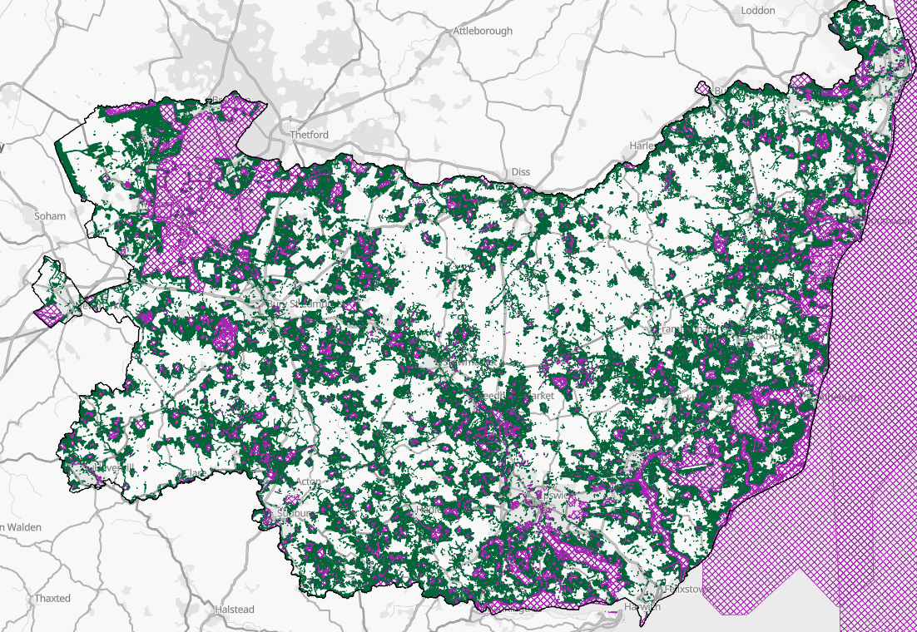
© Norfolk County Council 2025, contains data from OS MasterMap Crown Copyright and Database rights 2025 Ordnance Survey AC0000851272. Contains data reproduced with the permission of The Woodland Trust for use for LNRS purposes only. The data is subject to the conditions of their non-commercial licence. For any other uses contact ancienttreeinventory@woodlandtrust.org.uk. Contains public sector information licensed under the Open Government Licence v3.0. Biological records provided by Norfolk and Suffolk Biodiversity Information Service (NBIS and SBIS), acting on behalf of the contributing biological recorders, whom whose rights are recognised. The UK Habitat Classification System is used under licence from UKHab Ltd. No onward licence implied or provided. Please see https://ukhab.org/ for further details about the UK Habitat Classification System.
Priority will be given to applications that both support the Mid Suffolk BAP and the Suffolk LNRS.
Applications must address challenges and issues relating to water management. All applications must address flood management and water quality. Addressing water security is not mandatory but may benefit the strength of your application.
Nature-based approaches to water management are highly likely to also deliver benefits to nature recovery:
- Natural flood management approaches are likely to also result in habitat creation, expansion or enhancement
- Water quality improvements, through reducing run-off, increasing oxygen content, reducing siltation and nutrification that can be detrimental to wildlife
- Water security, through storing water for agricultural use, reducing water use, and ironing out peaks and flows to provide a more constant flow of water that also benefits riparian ecology
Delivering benefits in water management will also deliver benefits for our communities, for example through:
- Reduced obstruction of roads due to flooding
- Preventing property damage from flooding
- Improved water quality for recreation
- Improved food security and lower food costs
Applicants should consider how their project will contribute towards water management in addition to delivering benefits to nature recovery and local communities. Projects that have water management at their core are favoured and the assessment process reflects this. Identification of both the need for water management interventions, through public consultation and/or by addressing issues identified by regulatory bodies, such as the Environment Agency or Suffolk County Council, and the benefits these will deliver, is a requirement of the grant assessment process.
Modelling is likely to be an integral part of projects of this nature, in particular for natural flood management. Modelling helps identify where interventions may be best located and to ensure they don’t cause unforeseen harm to locations elsewhere.
Some interventions intended to address water management issues may require consent from relevant bodies, for example permits and licences may be required from the Environment Agency for the following works:
- Flood Risk Activity Permits – to assess any changes to flood risk from proposed activities.
- Water resource, including: Impoundment licence – for introducing into or removing any feature from a channel; Transfer licence – for redirecting water, and: Abstraction licence – for removal of water
- Waste
- Herbicide agreements - to apply herbicides in or near water
- Fish movements - if fish need to be temporarily or permanently moved, e.g. for a river restoration project or pond / lake restoration
Planning permission may be required for some engineering works, from Mid Suffolk District Council or Suffolk County Council.
Works that impact upon Public Rights of Way will require permission from Suffolk County Council.
Applicants will need to demonstrate that, where relevant permissions are required, these are either in place, or there is a process to obtain them.

Payment
For revenue and pre-project cost applications, funding will be released on receipt of a signed offer letter. For capital applications, funding will be released on receipt of invoices/receipts showing that expenditure has taken place.

Projects must complete within 12 months of funding being awarded, unless otherwise stated. Where the wider project will continue for longer than 12 months, the elements relevant to this grant application must be completed within 12 months, unless otherwise agreed.

If any service/project fails to meet any of the conditions contained in the grant offer letter or the agreed targets/outputs, then consideration will be given to the grant offer being withdrawn and any grant monies already paid being recovered together with any interest applicable.

Contact

If you have any queries, would like more information or would like to discuss a potential project and funding application, please email the Grants Team at BMSDCGrants@baberghmidsuffolk.gov.uk.

