Contents
1. Introduction 2
2. Community Nature Recovery Grants 2
2.1. Small Grants 2
2.2. Large Grants 3
3. Terms and Conditions 3
3.1. Organisations 3
3.2. Community Interest Companies 3
3.3. Ineligible Organisations 4
3.4. VAT 4
3.5. Conditions 4
3.6. Outcomes and Indicators 5
3.7. Community Need and Benefit 6
3.8. Timelines 6
3.9. Security of Tenure 6
3.10. Offer Letters 7
4. Small Grants 7
4.1. Eligible Projects 7
4.2. Process 7
4.3. Pre-Application 7
4.4. Application Process 7
4.5. Assessment 8
4.6. Payment 8
5. Large Grants 8
5.1. Pre-Project Costs 8
5.2. Capital Projects 8
5.3. Revenue Costs 8
5.4. Process 9
5.5. Pre-Application 9
5.6. Application Process 9
5.7. Assessment 9
5.8. Payment 10
6. Contact 10

Introduction

Mid Suffolk District Council offers Community Grants to organisations that deliver community support, projects or activities within Mid Suffolk. These notes are designed to help you complete our Community Nature Recovery Grant application forms and we suggest that you read them through fully before you complete the forms.

Details on our available Grants can be found on our website. View information on Community Grants in Mid Suffolk.

Community Nature Recovery Grants

The Community Nature Recovery Grant is aimed at supporting our communities to help local wildlife to recover, through the creation and management of habitats and species.

Through this funding, we want to:
- Support delivery of the Mid Suffolk District Council Biodiversity Action Plan, through projects that contribute towards the retention, enhancement and creation of the priority habitats, or support the priority species.
- Support delivery of the Suffolk Local Nature Recovery Strategy, through projects that support the priority habitats, assemblages and species, or that take place in locations identified within the mapping as important for nature recovery.
- Support people to make new connections with the natural environment, through providing increased access to natural spaces, opportunities for volunteering, educational resources, and skills development.
- Support our communities, through environmental co-benefits, such as natural flood management, improving air and water quality, community food production and improving health and wellbeing.
Applicants can only make one application per project per financial year to the Community Nature Recovery Grant. Priority will be given to new applicants. Match funding is not required, though is encouraged.

Applications must demonstrate a clear need for their project/organisation within Mid Suffolk and wider community benefit. Applications which are not fully filled or lack required supporting documentation will not be considered eligible.

The Grant is available at two levels:

Small Grants
Eligible towards revenue, capital or pre-project costs or activities, up to 100% of total project costs (to a maximum grant of £2,000). The Small Grants scheme is intended to support smaller schemes, with a simplified application process to reflect the lower value of applications.

Large Grants
Eligible towards revenue, capital or pre-project costs or activities, up to 100% of total project costs (from £2,000 to a maximum grant of £50,000).

Terms and Conditions

Organisations
Applications for grants will only be considered from constituted Voluntary, Community, Faith and Social Enterprise (VCFSE) organisations which:

- Provide a service for the benefit of Mid Suffolk residents
- Are capable of obtaining from its own funds or other sources sufficient funding to cover the total project costs
- Are financially viable, as evidenced by audited or independently examined accounts.
- Have Safeguarding, Health and Safety and Equal Opportunities policies for employees, volunteers and attendees
- Provide services which align with the Council’s priorities, do not duplicate services already being provided/grant aided, and will meet proven identified needs. In the case of 'start up' initiatives, evidence of the need for the new service needs to be supported and reflect community demand

Community Interest Companies
A Community Interest Company (CIC) is a form of limited company that may be limited by shares or guarantee. The Council only accepts applications for Community Grants from CICs that are limited by guarantee.

A CIC operates like a standard limited company, with directors overseeing its activities, but its purpose must benefit the community, not generate profit for members. The concept of community can have a wide range of meanings, from the population to a section of the community, such as the residents of a particular area or a group of people suffering from a particular disadvantage.

If directors are also the only members, they must act collectively, share responsibility, and comply with collective decisions—even if they personally disagree. CIC directors can be paid a salary which is treated as an employee’s wage for tax purposes. Therefore, to be eligible for Council funding, a CIC must:

- Be limited by guarantee
- Have at least two unrelated directors
- Evidence that no single director has excessive control (i.e., no individual holds 50% or more of voting rights; has the power to appoint/remove directors; or is listed as a Person with Significant Control (PSC) with Companies House)

Your governing documents must demonstrate:

- A clear social purpose
- That profits are not distributed
- A minimum of two directors, with no Person with significant Control (PSC) registered with Companies House
- A quorum of at least two directors for meetings
- An asset lock to ensure remaining assets go to a similar organisation upon closure (if you have not nominated an asset lock body within your articles of association, you will need the regulators consent to transfer any residual assets)

Trading: Your enterprise should be generating income through trading or contracts (or planning to). Grants are generally not awarded for core running costs unless an income stream is already established.

Accounts: You must provide annual accounts showing:

- All income sources, including traded income, grants, and donations. If this is not clearly shown, extra information will be required.
- Show defined expenditure for the past 12 months.

You may also need to disclose:

- The number of directors who are paid employees
- The salary levels of paid directors
- Your last CIC34 Annual CIC Report

Ineligible Organisations
Community Nature Recovery Grants are not available for:

- Private individuals
- For-profit businesses
- Revenue funding for statutory duties
- Schools where there is no wider community benefit
- Churches where there is no wider community benefit
- Community groups without an independent bank account
- Activities promoting religious or political beliefs
- Services commenced or goods ordered prior to Grants being awarded

VAT
If your organisation is registered for and can reclaim VAT, any Grant awarded will be exclusive of VAT. If your organisation is unable to reclaim VAT, Grants awarded will be inclusive of VAT.

Conditions
- Projects should deliver both biodiversity and community benefits, and these benefits as well as project outcomes should be identified as part of the application process.
- All services/projects need to be delivered within a period of 12 months, unless justification is given for a different timescale. By the end of the period the services/project should be sustainable or have a plan in place for future funding.
- To ensure best value for money, a minimum of two quotes are required for capital purchases and expenditure.
- Projects cannot be retrospectively funded, i.e. applications cannot be submitted for projects or purchases already completed/commenced.
- Applicants will need to provide evidence of their land tenure, usually ownership (freehold) or a lease with at least 10 years un-expired at the time of application and evidence of permission for the proposed project from a landlord.
- A grant approval given in advance of other decisions required from the Council does not imply that any other form of consent by the Council will be forthcoming, such as Planning Permission, Building Regulations approval or Community Infrastructure Levy bids.
- Some applications will need to be supported with additional documentation so that an accurate and complete understanding of the proposal is provided. The amount of information and supporting documentation to be provided should be proportionate to the project, namely its size, complexity, and cost, and this can be discussed with the Grants Team prior to application submission.
- Where the application is for a project or service that extends beyond the boundaries of the Mid Suffolk area, consideration will be given to the funding secured from neighbouring local authorities when assessing the level of Mid Suffolk support applicable.
- The Council reserves the right to request a copy of any applying organisation’s policies or constitution prior to an application being assessed or funding being released to a successful applicant.
- If any conditions are breached, the Council reserves the right to seek recovery of all or part of the grant. If you do not immediately repay these monies, when requested to do so by the Council, the Council reserves the right to commence County Court proceedings for recovery of the outstanding monies, together with interest and Legal costs.
- Our decisions are final and there is no appeal process.
- Funding will not be released until the full funding package for the project has been evidenced.

Outcomes and Indicators
The Application Form requires outcomes and indicators to be provided. If your application for funding is successful, it gives us an agreed framework within which we can monitor progress.

Outcomes are the intended results a project or organisation aims to achieve. These will relate to the difference a project or grant has made.

Indicators are the means in which outcomes will be measured and can be quantitative (such as number of people using a facility within a specified timeframe) or qualitative (such as user feedback).

Examples of potential outcomes and indicators are below:
Outcome | The parish meadow will have an increase in native wildflower species resulting from improved management and increase volunteer participation
Indicator 1 | Increase of X in the number of flowering species, as compared with Y number currently recorded
Indicator 2 | Increase in the number of volunteer days from X in the previous 12 month period to Y

Outcome | The pond will hold more water for more of the year, providing a more stable aquatic environment and an educational resource for the local school
Indicator 1 | Increased area of marginal vegetation compared to original area of marginal vegetation
Indicator 2 | Increased number of educational visits per year for children from the local school compared to the previous year

Outcome | The Community Tree Nursery will provide free trees of local provenance for planting across the parish and develop skills in propagation
Indicator 1 | Number of free trees given out annually
Indicator 2 | Number of volunteers involved in running the nursery

Outcome | Coppicing the woodland will restore ground flora, improve access for the local community and provide a focal point for volunteering
Indicator 1 | Increase in woodland flowers compared to number prior to coppicing
Indicator 2 | Increased number of visitors to the woodland compared to number prior to coppicing

Community Need and Benefit
In assessing your application priority will be given to applications that demonstrate wide community engagement, community involvement and evidenced benefit. Any application for funding to support or extend existing community assets and services must also demonstrate and evidence clear community need and evidence this.
Applicants should be clear that priority will be given to applications with the widest community benefit.

Timelines
Applications must provide a timeline for delivery. This will need to cover:
- Project start date
- Key stages during the project
- Project end date
The timeline needs to be realistic and achievable. This includes consideration given to:
- Relevant environmental legislation, such as avoiding work during periods that may impact on protected species
- Carrying out planting during the appropriate season
- Expected lead-in time for contractors
- Time required for legal agreements

Security of Tenure
Applicants must either:
- Own the land to which the application relates (freehold)
- Have a lease agreement with at least 10 years remaining (leasehold)
- Have written confirmation that the landowner agrees to the proposed project

Offer Letters
Successful applicants will receive an offer letter setting out conditions, outcomes and the period during which the service/project needs to be completed. Offers are valid for 4 weeks, and after this period the offer will expire.

If any service/project fails to meet any of the conditions contained in the grant offer letter or the agreed targets/outputs, then consideration will be given to the grant offer being withdrawn and any grant monies already paid being recovered together with any interest applicable.

Small Grants

Eligible Projects
Examples of eligible projects are:
- Community orchard creation
- Tree and hedge planting
- Wildflower meadow creation
- Pond restoration
- Installing bird, bat and other boxes
- Creating a community tree nursery
- Improving public access
- Providing interpretation
- Purchasing tools and equipment for habitat and species management
Grants are not available for:
- Running costs
- Private individuals
- For-profit businesses
- Statutory duties
- Schools where there is no wider community benefit
- Churches where there is no wider community benefit
- Community groups without an independent bank account
- Activities promoting religious or political beliefs
- Services commenced or goods ordered prior to Grants being awarded

Process
Applications can be submitted from 19th January 2026. Applications will be scored and applicant organisations will be informed of the outcome of their application within 14 days of receipt.

Pre-Application
Applicants may wish to have pre-application discussions with the Grants Team, or submit a Grant Enquiry Form. Site visits to prospective projects may also be available.
  - Application Process
Completed grant applications to be emailed to: BMSDCGrants@baberghmidsuffolk.gov.uk by no later than the stipulated deadline.

Each completed application form to be accompanied by a copy of latest accounts and (if a capital project) a minimum of 2 quotes for any proposed works, or a valid reason if a single quote is provided. Copies of Policies (Equal Opportunities, Health & Safety, Child and Adult Safeguarding) should also be linked to or provided.
  - Assessment
All applications will be scored by a publicly available scoring matrix. Applications which score under 50% on the Community Nature Recovery Grant Scoring Matrix will not be considered eligible for funding.
All applications will be required to support the delivery of the Mid Suffolk Biodiversity Action Plan (BAP)’s actions. Priority will be given to applications that demonstrate clearly how habitats and/or species will directly benefit from the project.

Payment
For revenue and pre-project cost applications, funding will be released on receipt of a signed offer letter. For capital applications, funding will be released on receipt of invoices/receipts showing that expenditure has taken place. Projects must complete within 12 months of funding being awarded.

If any service/project fails to meet any of the conditions contained in the grant offer letter or the agreed targets/outputs, then consideration will be given to the grant offer being withdrawn and any grant monies already paid being recovered together with any interest applicable.

Large Grants

A range of projects and costs can be applied for through the Community Nature Recovery Grant – Large Grants.

Pre-Project Costs
Funding is available for work required to support a full application, helping to develop the project. For example, this could be for ecological surveys, soil surveys and modelling. There is a maximum of £5,000 for pre-project costs. If subsequently, an application is submitted for a project supported by the pre-project work, the pre-project costs and project application together cannot exceed the maximum £50,000 available per application.

Capital Projects
Funding is available for work to create, enhance and restore habitat, such as pond creation or restoration, fencing for deer protection, the purchase of trees and hedging, equipment and machinery for habitat management.

Funding is available towards land purchase to support habitat creation, retention and enhancement, where this secures or increases public access.

Funding is not available towards projects where there is no community or public access.

Revenue Costs
Funding is available towards the delivery and running costs of new and existing community environmental groups and services. This may include establishing allotments, projects that support increased access and engagement with the natural environment, improve social contact and improve wellbeing.

Costs which can be applied for can include the following:

- Management and maintenance of habitats, tools and equipment
- Fuel for powered machinery
- Training relevant to the project, such as certification for tool use and first aid
- Communications and outreach
- Volunteer expenses
- Full cost recovery

Ineligible projects and costs include the following:
- Core running costs
- Purchase of equipment where there is no clear evidence of need
- Fundraising events

Process
There will ordinarily be two application windows per financial year. However, the fund will only be open for one application window in the financial year ending March 2026. This opens on 19th January and closes on 16th March.

The first application window in the 2026-2027 financial year will open on 15th June and close on 10th August. Successful applicants will be awarded funding for the 2026/27 financial year.

The second application window will open 16th November and close 18th January 2027. Subsequent windows will be confirmed at a later date.

Pre-Application
Applicants are required to submit a Grant Enquiry Form prior to submitting a full application. Applicants may wish to have pre-application discussions with the Grants Team. Site visits to prospective projects may also be available.
  - Application Process
Applications will be invited following the submission of an eligible Grant Enquiry Form.

Completed grant applications to be emailed to: BMSDCGrants@baberghmidsuffolk.gov.uk by no later than the stipulated deadline.

Each completed application form to be accompanied by a copy of latest accounts and (if a capital project) a minimum of 2 quotes for any proposed works, or a valid reason if a single quote is provided. Copies of Policies (Equal Opportunities, Health & Safety, Child and Adult Safeguarding) should also be linked to, or provided.
  - Assessment
All applications will be scored by a publicly available scoring matrix. Applications which score under 50% on the Community Nature Recovery Grant Scoring Matrix will not be considered eligible for funding.
All applications will be required to support key habitats and species identified by the Mid Suffolk Biodiversity Action Plan (BAP). Priority will be given to applications that demonstrate clearly how habitats and/or species will directly benefit from the project. These are:
Priority Species
- Swifts
- Hedgehogs
- Bumblebees
- Toads
- Native Black Poplar
Priority Habitats
- Arable Field Margins and Hedgerows
- Calcareous Grassland
- Lowland Meadows
- Open Mosaic (and Natural Regenerating Habitat)
- Ponds
- Traditional Orchards
Priority will be given to applications that support delivery of the Suffolk Local Nature Recovery Strategy (LNRS)’s aims and ambitions:
- Create, enhance and expand priority habitats
- Reconnect fragmented landscapes
- Recover and protect key species
- Support sustainable farming and land management
- Restore wetlands, rivers, and peatlands
- Safeguard and enhance coastal habitats
- Expand woodland and tree cover
- Integrate nature into towns and cities
- Empower communities and landowners
- Deliver co-benefits for climate, health, and the economy

The LNRS’s Mapping Tool shows a breakdown of areas within Mid Suffolk which are considered Areas of Particular Importance for Biodiversity (APIB) or Areas that Could Become Important for Biodiversity (ACB). Applicants are asked to identify whether their project takes place within an area considered an APIB or ACB, with priority afforded to those projects which clearly take into consideration the recommendations of the LNRS.
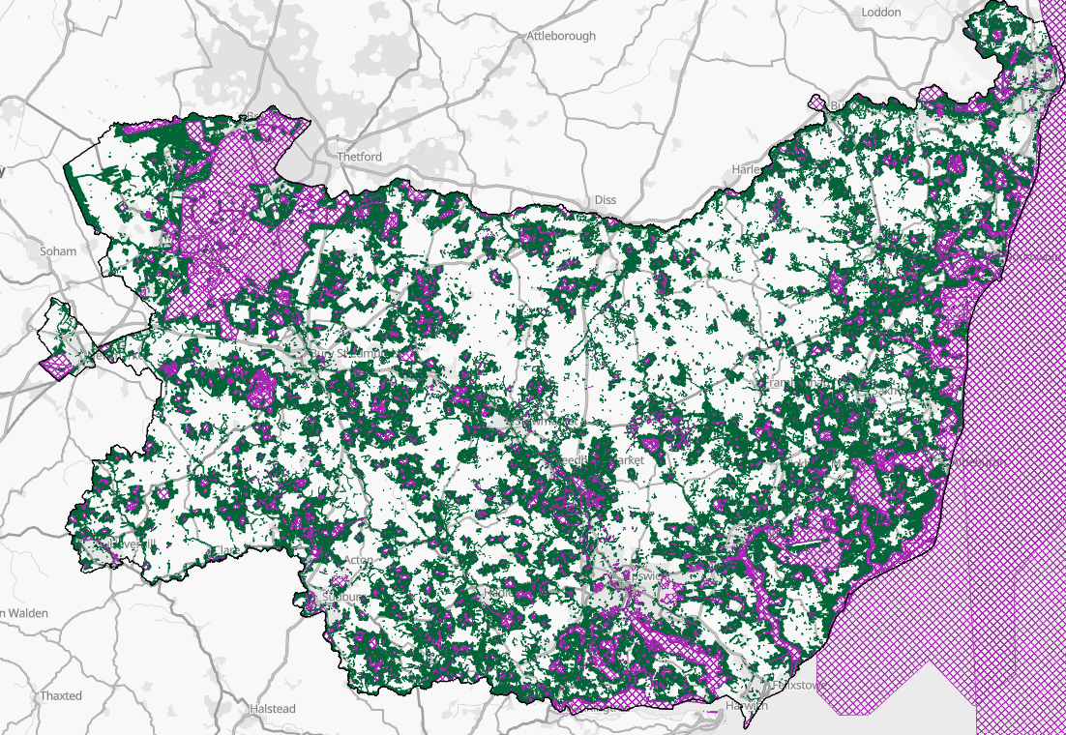
Priority will be given to applications that both support the Mid Suffolk BAP and the Suffolk LNRS.

Payment
For revenue and pre-project cost applications, funding will be released on receipt of a signed offer letter. For capital applications, funding will be released on receipt of invoices/receipts showing that expenditure has taken place. Projects must complete within 12 months of funding being awarded, unless otherwise stated.

If any service/project fails to meet any of the conditions contained in the grant offer letter or the agreed targets/outputs, then consideration will be given to the grant offer being withdrawn and any grant monies already paid being recovered together with any interest applicable.

Contact

If you have any queries, would like more information or would like to discuss a potential project and funding application, please email the Grants Team at BMSDCGrants@baberghmidsuffolk.gov.uk.

